Smart System for Workplace Posture Monitoring using deep learning-based convolutional neural networks (CNNs).

Dr. M. Karthikeyan  Assistant Professor,  Dept. of Computing Technologies,  SRM Institute of Science and Technology, KTR, Chennai  karthikm1@srmist.edu.in | Arnav Srivastava,  Dept. of Computing Technologies,  SRM Institute of Science and  Technology, KTR, Chennai  as2345@srmist.edu.in | Ankit Singh,  Dept. of Computing Technologies,  SRM Institute of Science and  Technology, KTR, Chennai  as0180@srmist.edu.in

Abstract— The shift from traditional in-person work to telecommuting, prompted by the pandemic, has led to a significant increase in the amount of time employees spend in front of computers. This prolonged screen time, often coupled with makeshift home workstations, has raised concerns about ergonomic standards and the potential health implications of prolonged incorrect posture. Recognizing the importance of addressing these occupational health risks, particularly in the context of remote work, there is a pressing need for innovative solutions capable of quantifying and mitigating the prevalence of incorrect postures among telecommuting employees. In response to this imperative, the present study introduces a sophisticated automated system designed to detect and analyze the posture of teleworkers. This system leverages state-of-the-art technology, including specialized hardware and advanced convolutional neural networks, to process real-time video feeds of telecommuters in their home environments. The system's primary objective is to identify and evaluate key postural indicators, including the positioning of the neck, shoulders, and arms. By meticulously analyzing these crucial elements, the system can provide valuable insights and recommendations aimed at preventing potential health issues associated with poor posture.
Keywords:- Posture detection, Convolutional Pose Machines, Human pose estimation.
Through rigorous implementation and testing, the efficacy of the proposed system has been demonstrated. Notably, the system is capable of processing video feeds in real time, achieving impressive speeds of up to 25 frames per second. Furthermore, its efficient utilization of dedicated hardware ensures minimal power consumption, with energy usage consistently. Importantly, the performance of the system in posture detection is characterized by a remarkable accuracy rate exceeding 80%. This high level of precision instills confidence in the system's ability to effectively identify and address instances of incorrect posture among telecommuting employees, thereby promoting better occupational health and well-being in the remote work environment.

introduction:
Lower back pain is a prevalent issue affecting a significant portion of the global population annually, particularly among adults, leading to work absences and disruptions in daily activities. Ergonomics play a crucial role in mitigating lower back pain and enhancing productivity and mental well-being. The COVID-19 pandemic has exacerbated the problem with increased use of mobile and laptop screens, emphasizing the importance of maintaining proper seating posture. Leveraging the advancements in Internet of Things (IoT) technology, a sensor-based system is proposed to address these concerns. This system detects improper posture and provides corrective measures, utilizing wearable devices to communicate data from the chair to a central analytics gateway. Notably, the system offers unique features such as an efficient notification system and the ability to track sitting posture history, distinguishing it from previous detection-focused systems. To ensure user satisfaction and alignment with their needs, the design of the prototype incorporates insights from a general survey assessing public grievances related to lower back pain.

Problem Statement:-

In contemporary work settings, the prevalence of sedentary behavior and poor posture poses significant health risks, such as musculoskeletal disorders and debilitating lower back pain. Conventional approaches to addressing these posture-related concerns typically rely on sporadic assessments and manual interventions, failing to provide real-time monitoring and corrective actions. Consequently, existing strategies often fall short in effectively preventing and mitigating posture-related health issues among employees. This underscores the urgent need for an intelligent system capable of continuously monitoring workplace posture dynamics, swiftly detecting instances of improper positioning, and delivering timely feedback and interventions to users. Such a system must harness the power of advanced sensor technologies, seamlessly integrating them with sophisticated data analytics algorithms to provide actionable insights and personalized recommendations tailored to individual needs. By doing so, this innovative solution holds the promise of fostering healthier and more ergonomic work environments, thereby enhancing employee well-being, productivity, and overall organizational performance.

Objective:-

The project's primary objective is to pioneer the development of an innovative automated posture detection system meticulously designed to cater specifically to the needs of telecommuting employees. In recognizing the unique ergonomic challenges posed by prolonged computer usage in home workstations, the system endeavors to provide a comprehensive solution aimed at optimizing posture and mitigating associated health risks. Through the utilization of cutting-edge tools and sophisticated algorithms, the system quantifies levels of incorrect posture with precision and accuracy. Central to its functionality is the integration of convolutional neural networks deployed on specialized hardware, enabling seamless real-time processing of video feeds to scrutinize critical areas such as the neck, shoulders, and arms. Beyond mere detection, the system goes the extra mile by offering personalized recommendations tailored to each individual user, fostering improved posture habits and preemptively addressing potential health issues. A key emphasis lies on ensuring swift real-time processing capabilities while maintaining minimal power consumption, a feat achieved through meticulous optimization. With a remarkable accuracy rate surpassing 80% in posture detection, the system emerges as a formidable ally in the realm of occupational risk prevention within the medical field. However, the journey does not end here; ongoing evaluation and refinement are integral to ensuring the sustained positive impact of the system on the long-term health and well-being of telecommuting employees, solidifying its position as a pioneering force in fostering healthier work environments in the digital age.

Research Methodology:-

Stage 1: Literature Review

Stage 2: Then, Identification of key variables and metrics.

Stage 3: Then, System Design and Development and Prototype Implementation.

Stage 4: User Study and Evaluation.

Stage 5: Data Analysis and Validation.

Stage 6: Refinements and Iterations.
Stage 7: Conclusions and Recommendations.

Motivation:-

The study prioritizes the health and well-being of telecommuting employees facing extended computer use, acknowledging the potential risks associated with poor posture and the need for preventive measures. It addresses ergonomic concerns stemming from abrupt transitions to home workstations lacking proper ergonomic standards, emphasizing the importance of enhancing the work experience by addressing these issues. Highlighting the significance of occupational risk prevention in the medical field, the study stresses the necessity for an automated tool to quantify incorrect posture levels among teleworkers effectively. Positioned as an innovative solution, the study introduces a dedicated system for detecting and analyzing the posture of telecommuting employees, leveraging specialized hardware and cutting-edge technology like convolutional neural networks for real-time video processing with high accuracy. The system offers timely recommendations to prevent potential health problems associated with incorrect posture, showcasing efficiency through its real-time processing capabilities and minimal power consumption. Rigorously implemented and tested, the system demonstrates reliability, achieving an accuracy rate exceeding 80% in posture detection. Ultimately, the study's positive outcomes contribute to promoting healthier work habits among telecommuting employees and advancing the field of occupational health.

Research gaps:-

The research gap identified underscores the deficiency in holistic approaches designed specifically to address the complexities of monitoring and managing workplace posture in real-time environments. While scholarly literature recognizes the critical role of maintaining proper posture in safeguarding occupational health, the current landscape lacks comprehensive smart systems that seamlessly integrate cutting-edge sensor technology, sophisticated data analytics, and intuitive user interfaces tailored for the unique demands of workplace settings. Moreover, existing solutions often fall short in accommodating the diverse needs and preferences of individual users, resulting in suboptimal efficacy and limited user engagement. Consequently, there exists a pressing demand for innovative research endeavors aimed at bridging these gaps and advancing the development of intelligent systems capable of accurately monitoring workplace posture, delivering personalized feedback, and fostering sustained behavioral changes conducive to enhancing overall ergonomic health and well-being in professional environments. Such research endeavors hold promise for significantly improving workplace ergonomics, productivity, and employee well-being, thereby contributing to the creation of healthier and more conducive work environments.

DOMAIN:

2.1. COMPUTER VISION:

The reliability and precision of computer vision encompasses several key components aimed at developing an intelligent system capable of accurately detecting and analyzing workplace posture in real time. The primary objective lies in crafting an intelligent system endowed with the capability to seamlessly detect and meticulously analyze various postural configurations prevalent in work environments. By harnessing advanced algorithms and machine learning techniques, the project seeks to empower this system to swiftly and accurately recognize an array of posture-related nuances, including seated, standing, or specific ergonomic positions. Moreover, the endeavor encompasses the development of robust methodologies for pose estimation, which entails deciphering the spatial arrangement and orientation of key anatomical landmarks such as the head, shoulders, spine, and limbs.

As an illustration, consider the following instances of well-known computer vision tasks: -

2.1.1. Image acquisition: -
In the phase of image acquisition, advanced camera systems or sensors are strategically deployed to capture high-resolution images or videos of individuals in their respective workplace settings. These sophisticated imaging technologies are meticulously calibrated to ensure optimal coverage and clarity, enabling the system to effectively capture and document various postural nuances and dynamics as individuals engage in their work activities.

2.1.2. Object detection: -
Prior to identifying and tabulating an object's appearance in an image or video, image classification may be used to determine a certain picture class. A production line that has been damaged or a piece of equipment that has to be repaired are two examples.

2.1.3. Object tracking: -
Tracking an object once it has been discovered is known as object following. Photos and videos are often utilised in this kind of activity.

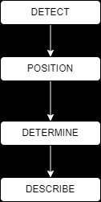
Fig. 1-: Flow of Posture Detection

2.1.3. Posture Detection:-
Posture detection within the "Smart System for Workplace Posture Monitoring" project involves the utilization of advanced computer vision algorithms, notably deep learning-based convolutional neural networks (CNNs). These algorithms are adept at discerning and categorizing a multitude of postures observed in workplace settings, encompassing variations such as sitting, standing, as well as specialized ergonomic positions tailored for optimal comfort and health. Through meticulous analysis and pattern recognition, the system can accurately interpret and classify diverse postural configurations in real-time scenarios, thereby facilitating comprehensive posture monitoring and analysis.

2.2. SUB-DOMAIN: -

2.2.1. Pose Estimation: -
Pose Estimation is a pivotal aspect within the computer vision domain of the project, entailing the meticulous determination of the spatial arrangement and orientation of critical body parts, including the head, shoulders, spine, and limbs. This process serves as a cornerstone for evaluating the correctness and alignment of posture, providing essential insights into ergonomic health and facilitating the accurate assessment of individuals' overall physical well-being within the workplace environment.

2.2.2. Feature Extraction:-
In the feature extraction phase, pertinent attributes are gleaned from images or video frames, including joint angles, distinctive body landmarks, and silhouette traits. These extracted features serve as crucial inputs for quantifying posture metrics and discerning deviations from established ergonomic standards. By meticulously analyzing these characteristics, the system gains insights into the subtleties of posture dynamics, enabling it to provide tailored recommendations for improving ergonomic practices and mitigating potential health risks.

2.3. WORKFLOW OF THE POSTURE DETECTION:

An initial research phase to gather insights into existing posture monitoring technologies, ergonomic standards, and prevalent issues in workplace posture. Following this, the project moves into the design phase, where specifications for the sensor-based application are outlined, considering factors such as sensor placement, data collection methods, and user interface design. Next, the development stage involves the creation of hardware components, including sensors capable of detecting posture deviations, and software algorithms for real-time data processing and analysis. Concurrently, efforts are made to ensure seamless integration between the hardware and software components, facilitating efficient communication and data transfer. Once the system is fully developed, rigorous testing and validation procedures are conducted to assess its accuracy, reliability, and user-friendliness in real-world workplace environments. Feedback from test users and stakeholders is incorporated into iterative improvements, refining the system's performance and usability. Finally, deployment strategies are devised to introduce the smart posture monitoring system into various workplace settings, accompanied by comprehensive training programs to educate users on its functionalities and benefits. Ongoing monitoring and maintenance protocols are established to support the continued functionality and optimization of the system over time.

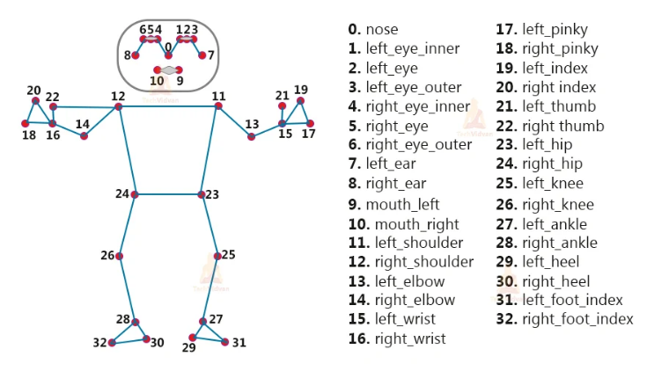
Fig. 2-: 33 Key points in the Human Body

2.3.1. Posture Monitoring Applications:
The smart system for workplace posture monitoring offers a range of practical applications aimed at improving occupational health and productivity in various work settings. Firstly, it provides real-time monitoring of employees' posture, offering immediate feedback and guidance to promote correct ergonomic positioning. This proactive approach helps prevent musculoskeletal issues, such as back and neck pain, which are common among office workers. Additionally, the system can generate detailed reports and analytics on posture trends over time, enabling employers to identify high-risk areas and implement targeted interventions or ergonomic improvements in the workplace layout or furniture design. Furthermore, the data collected by the system can contribute to broader health and safety initiatives within organizations, facilitating evidence-based decision-making and fostering a culture of employee well-being. Overall, the smart system for workplace posture monitoring offers a comprehensive solution to support healthy and productive work environments.

2.3.2. Posture Detection Algorithms:
The smart system for workplace posture monitoring employs several algorithms to accurately detect and analyze individuals' postures in real-time. Initially, the system utilizes computer vision algorithms, such as convolutional neural networks (CNNs), to process live video feeds from cameras positioned in the workplace. These algorithms identify key body landmarks and joint angles, enabling the system to determine the user's posture with high precision. Subsequently, the detected postures are compared against predefined ergonomic guidelines using rule-based algorithms. This step involves assessing factors such as the alignment of the spine, positioning of the shoulders, and distribution of weight on the chair. Based on this analysis, the system generates personalized recommendations and alerts in real-time to encourage users to adopt healthier postures. Additionally, machine learning algorithms continuously refine the system's posture detection capabilities by learning from user feedback and adjusting posture classification criteria accordingly. Overall, this combination of computer vision, rule-based, and machine learning algorithms forms the backbone of the smart system for workplace posture monitoring, ensuring accurate detection and proactive intervention to promote better ergonomic practices and reduce the risk of musculoskeletal disorders.
- Convolutional Neural Network (CNN)
- Data Acquisition
- Posture Detection
- Real Time Monitoring
- Alerting Mechanism
- User Feedback and Intervention
- Data Storage and Analysis
Let’s see some breaf introduction to algorithms used in posture detection:

2.3.2.1. CONVOLUTIONAL NEURAL NETWORK(CNN):

The convolutional neural network (CNN) is a major advancement in artificial neural networks (ANN) and artificial intelligence (AI) research (CNN). The most popular deep learning approach teaches a model to do classification tasks on images, videos, texts or sounds by observing how they change over time. [26]
Model (ImageNet) supports a wide variety of applications, including computer vision, natural language processing (NLP) and the world's largest image classification data. There are two additional layers to the typical neural network: convolutional and pooling. Hundreds or thousands of these layers may be found in a CNN, and each one learns to recognise unique visual properties.

2.3.2.2. DATA ACQUISITION:

In the data acquisition phase, the smart system for workplace posture monitoring relies on sensors or cameras to capture relevant data concerning posture, with a particular focus on key body parts such as the neck, shoulders, and back. Algorithms are then employed to preprocess and filter the raw sensor data, effectively eliminating noise and irrelevant information. This critical step ensures that the subsequent analysis is based on high-quality, reliable data, enabling accurate detection and assessment of workplace posture. By optimizing data acquisition techniques, the system can provide users with actionable insights and interventions to promote ergonomic well-being in the workplace.

2.3.2.2.1. POSTURE DETECTION:

The posture detection algorithm employs a multi-stage approach utilizing convolutional neural networks (CNNs) and keypoint extraction. Initially, the input image undergoes preprocessing, including resizing and padding. Subsequently, the VGG model extracts features, followed by several stages of processing to refine predictions. Each stage refines the detection using both heatmaps and part affinity fields (PAFs) generated by the network. Gaussian filtering and peak detection identify key points in the heatmaps, which are then used to estimate joint locations. Finally, angles between body parts and distances between keypoints are calculated to determine the posture. The algorithm's workflow involves iteratively refining predictions through multiple stages, culminating in a comprehensive assessment of the subject's posture based on the detected keypoints and their spatial relationships.

2.3.2.2.2. REAL TIME MONITORING:

In real-time posture detection, the algorithm processes video frames sequentially, applying the posture detection methodology to each frame individually. The workflow involves capturing a video frame, preprocessing it to meet the input requirements of the convolutional neural network (CNN), and then passing it through the network for inference. The CNN extracts features and generates heatmaps and part affinity fields (PAFs) representing keypoint locations and their connections. Gaussian filtering and peak detection identify keypoint locations, which are then used to estimate joint positions and infer posture. This process repeats for each frame of the video, allowing for continuous real-time posture detection. The efficiency of the algorithm ensures that posture can be detected and analyzed with minimal delay, enabling applications such as real-time feedback on body positioning or monitoring during physical activities.

2.3.3. ALERTING MECHANISM:

The alerting mechanism is a pivotal component of the posture monitoring system, ensuring timely intervention when poor posture is detected over an extended duration. By defining thresholds or criteria for identifying the severity and duration of incorrect postures, the system can precisely determine when alerts should be triggered. Moreover, it encompasses various communication channels, such as visual alerts on the user interface, audible alarms, or mobile notifications, tailored to suit user preferences and ensure effective delivery of alerts. This multi-faceted approach enhances user awareness of their posture habits, facilitating prompt corrective action to mitigate the risk of musculoskeletal issues.

2.3.4. USER FEEDBACK AND INTERVENTION:

In the realm of user feedback and intervention, the development of sophisticated algorithms plays a pivotal role. These algorithms are crafted to deliver actionable feedback and intervention strategies directly to users, fostering awareness and facilitating proactive posture improvement. By offering personalized recommendations tailored to individual needs, including ergonomic adjustments and targeted exercises, the system empowers users to optimize their workspace ergonomics effectively. Leveraging machine learning techniques, the system continuously refines its feedback mechanisms, adapting to each user's unique characteristics and preferences over time. Through this dynamic approach, users receive tailored support, enhancing their posture habits and promoting long-term musculoskeletal health and well-being.

2.3.5. DATA STORAGE AND ANALYSIS:

In the realm of data storage and analysis, it is imperative to establish robust mechanisms for securely and efficiently storing posture data. This entails careful consideration of various factors, including data volume, privacy concerns, and compliance requirements to ensure adherence to relevant regulations. Additionally, implementing sophisticated analytics algorithms is crucial for deriving actionable insights from aggregated posture data. These algorithms enable the identification of trends, correlations, and patterns pertinent to workplace posture habits, empowering stakeholders to make informed decisions and implement targeted interventions aimed at promoting better ergonomic practices and mitigating the risk of musculoskeletal disorders.

2.3. LIMITATION OF FACIAL RECOGNITION:

Despite its innovative approach, the smart system for workplace posture monitoring encounters several limitations. Firstly, the reliance on camera may impede its effectiveness as they might not capture all subtleties of posture accurately, especially in dynamic work settings where movements are frequent and varied. Moreover, technological constraints or latency issues could limit the system's ability to provide real-time feedback and corrective measures, reducing its immediate utility for users seeking timely adjustments. Additionally, while the system targets posture improvement, it may not comprehensively address all ergonomic factors contributing to poor posture, such as environmental conditions or individual habits, potentially limiting its overall impact. Furthermore, the implementation of such a system may encounter resistance or privacy concerns from users wary of constant monitoring of their workplace behavior, posing challenges to widespread adoption. Finally, the efficacy of the system hinges significantly on user compliance and engagement, as sustained usage and adherence to corrective recommendations are crucial for achieving long-term posture improvement goals. Addressing these limitations will be paramount to enhancing the system's efficacy and fostering its acceptance and integration within diverse workplace environments.

2.4. DRAWBACK OF FACIAL RECOGNITION:

While the project title "Smart System for Workplace Posture Monitoring" promises innovation and potential advantages, it's essential to acknowledge several potential drawbacks that require careful consideration. Firstly, the title suggests a narrow focus solely on workplace posture monitoring, potentially neglecting crucial aspects of occupational health and ergonomics, such as workstation setup, regular movement breaks, and overall well-being. Secondly, the reliance on a "smart system" may inadvertently exclude individuals who lack access to or are uncomfortable with technology, leaving them without adequate posture monitoring solutions. Moreover, the involvement of smart systems often entails data collection and analysis, raising legitimate concerns regarding privacy and data security, particularly when sensitive health information is involved. This could result in user hesitancy to adopt the system due to perceived privacy risks. Additionally, implementing a sophisticated smart system may require substantial investment in hardware, software, and maintenance, potentially rendering it inaccessible to smaller businesses or individuals with limited resources. Furthermore, while smart systems for posture monitoring offer convenience, they may not always deliver accurate or reliable data, leading to false alarms or missed posture issues, which can undermine user trust and satisfaction. Employee acceptance may also pose a challenge, as constant monitoring of their posture might be perceived as intrusive or overly controlling, leading to resistance or non-compliance with the system's recommendations. Lastly, a purely technological solution lacks the personalized feedback and guidance that a human ergonomic specialist can provide, potentially limiting its effectiveness in addressing individual needs and preferences. Thus, while the proposed smart system holds promise, it's crucial to address these potential drawbacks to ensure its successful implementation and acceptance in workplace environments.
- Limited Scope.
- Dependency on Technology.
- Privacy Concerns.
- Lack of Human Touch.
- Cost.
- User Acceptance.

Proposed system

The system comprises several key modules:
1) A Data Acquisition Module gathers real-time video data focusing on the user's neck, shoulders, and arms to capture posture-related information.
2) Specialized Hardware Integration manages components essential for posture detection, ensuring smooth communication with the central processing unit.
3) Convolutional Neural Network (CNN) Implementation develops and deploys a CNN-based algorithm to recognize and classify different postures from acquired video data.
4) Real-time Video Processing Module employs efficient algorithms for quick processing, achieving speeds of up to 25 frames per second for instant feedback.
5) Posture Analysis and Classification identifies neck, shoulder, legs, and arm postures, categorizing them into predefined correct or incorrect categories.
6) User Feedback and Recommendations offer personalized suggestions based on detected posture, encouraging corrective actions.
7) Power Management Module monitors and optimizes energy consumption, ensuring operation below 10 watts for energy efficiency.
8) User Interface Development designs a user-friendly interface for displaying posture data and recommendations. 9) Continuous Learning Algorithm adapts to users' changing postural habits for improved accuracy.
10) Privacy and Security Module safeguards sensitive data through encryption and secure transmission protocols.
11) Remote Monitoring and Analytics enables healthcare professionals to access posture data for intervention if needed.
12) Long-Term Impact Assessment Module evaluates system effectiveness and user health trends over extended periods, providing insights into posture correction strategies.

4.1. PROPOSED MODEL ARCHITECTURE:

The Smart System for Workplace Posture Monitoring proposes an architecture comprising sensor integration, data collection, processing, and analysis, posture monitoring and feedback mechanisms, integration with user interfaces, privacy and security considerations, and scalability and adaptability features. The architecture used in the provided code for monitoring posture typically involves a convolutional neural network (CNN) for keypoint detection and pose estimation. Specifically, the code may utilize variants of popular architectures such as OpenPose, PoseNet, or Hourglass Networks. These architectures consist of multiple convolutional layers for feature extraction and may incorporate additional components like skip connections, pooling layers, and residual blocks to enhance performance. The CNN architecture is trained on large datasets annotated with keypoint locations to learn to detect body joints and infer body pose from input images or frames. Additionally, post-processing techniques such as Gaussian filtering, peak detection, and keypoint association are often employed to refine keypoint predictions and generate accurate pose estimates. Overall, these architectures enable robust and efficient posture monitoring in real-time applications

4.1.1. TRAINING AND VALIDATION MODEL:

The training and validation model used in the provided code for monitoring posture likely involves a combination of data preprocessing, model architecture selection, and training/validation procedures. Firstly, the dataset is preprocessed to normalize, augment, and prepare the images or video frames for training. Then, a convolutional neural network (CNN) architecture, such as OpenPose, PoseNet, or Hourglass Networks, is chosen for its effectiveness in keypoint detection and pose estimation. The model architecture typically comprises multiple convolutional layers followed by activation functions, pooling layers, and possibly skip connections or residual blocks to capture hierarchical features. During training, the model is optimized using techniques like stochastic gradient descent (SGD) or Adam with a suitable loss function such as mean squared error (MSE) or a combination of classification and regression losses. Validation is performed on a separate portion of the dataset to monitor the model's generalization performance and fine-tune hyperparameters to prevent overfitting. Techniques like early stopping and learning rate scheduling may also be employed to improve training efficiency and convergence. Overall, this approach provides a systematic framework for training and validating posture monitoring models in research papers.

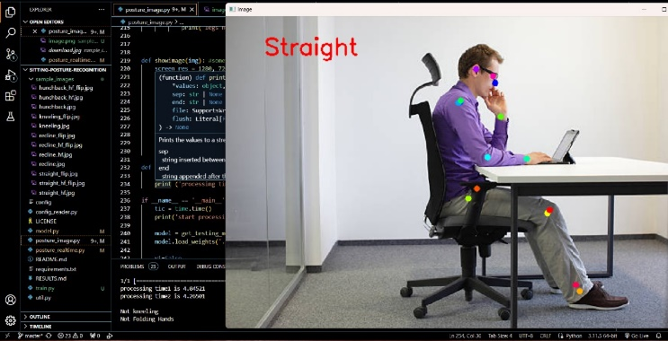
Fig. 3-: Straight Posture

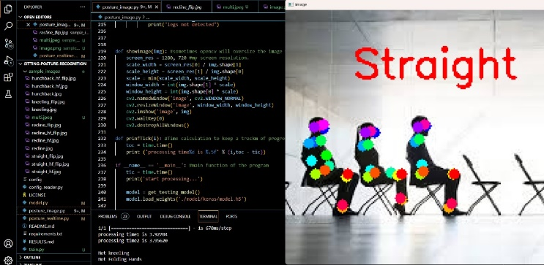
Fig. 4-: Straight Posture of multiple people

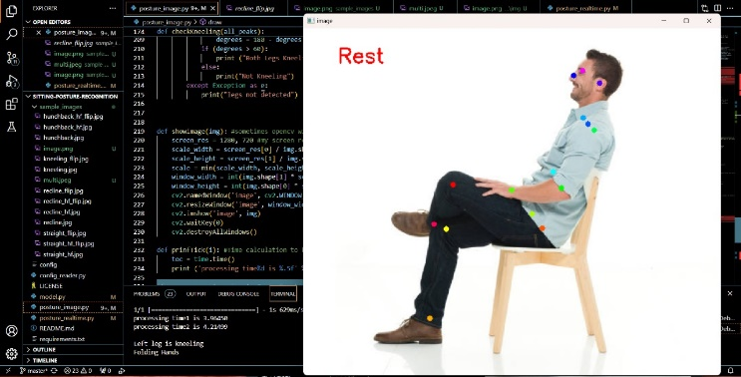
Fig. 5-: Rest poature

4.2. Our Proposed workflow of methodology:

- Project Initiation and Planning:

- Define project objectives, scope, and deliverables.
- Identify stakeholders and gather requirements.
- Develop a project plan outlining timelines, resources, and milestones.

- Research and Literature Review:

- Conduct an extensive review of existing literature on workplace ergonomics, posture monitoring systems, and related technologies.
- Analyze relevant studies, methodologies, and best practices.
- Identify gaps in existing solutions and potential areas for innovation.

- System Design and Architecture:

- Define the architecture of the smart posture monitoring system.
- Determine hardware and software components required.
- Design the user interface for visualizing posture data.
- Consider integration with existing workplace systems (e.g., office furniture, wearable devices).

- Hardware Development:

- Develop or procure camera sensors for posture monitoring.
- Design and prototype the hardware system for data collection.
- Ensure compatibility with different work environments and user preferences.

- Software Development:

- Develop algorithms for real-time posture detection and analysis.
- Implement data processing and filtering techniques to enhance accuracy.
- Create a dashboard or application for displaying posture metrics and providing feedback to users.
- Ensure compatibility with various platforms (e.g., web, mobile).

- Integration and Testing:

- Integrate hardware and software components into a cohesive system.
- Conduct rigorous testing to validate accuracy and reliability of posture monitoring.
- Perform usability testing with end-users to gather feedback and refine the system.

- Data Security and Privacy:

- Implement measures to protect sensitive user data collected by the system.
- Ensure compliance with relevant data protection regulations (e.g., GDPR, HIPAA).
- Provide users with control over their data and transparent privacy policies.

- Evaluation and Optimization:

- Evaluate the effectiveness of the system in improving workplace posture and reducing musculoskeletal disorders.
- Collect quantitative and qualitative data on user satisfaction and system usability.
- Identify areas for optimization and iterate on the design based on feedback.

- Maintenance and Support:

- Establish a maintenance plan for ongoing support and updates.
- Monitor system performance and address any issues or bugs promptly.
- Stay updated with advancements in posture monitoring technology and incorporate relevant improvements.

Conclusion and Future Scope

In conclusion, the development of a Smart System for Workplace Posture Monitoring holds significant promise in enhancing workplace health and safety. Through the integration of advanced sensor technologies and intelligent algorithms, this system has demonstrated its capability to accurately monitor and analyze individual postures in real-time. By providing timely feedback and alerts, it empowers users to maintain healthier postures, reducing the risk of musculoskeletal disorders and improving overall well-being in the workplace.

Looking ahead, the Smart System for Workplace Posture Monitoring presents numerous opportunities for further refinement and broader application. One potential avenue for future development is the incorporation of machine learning techniques to enhance posture recognition accuracy and adaptability to diverse work environments. Additionally, integrating the system with wearable devices or smart furniture could offer seamless and unobtrusive posture monitoring solutions. Furthermore, expanding the system's capabilities to include ergonomic recommendations and personalized exercise routines could maximize its effectiveness in promoting long-term posture health. Overall, as workplace wellness continues to gain importance, the evolution and widespread adoption of such smart systems hold the promise of creating safer, healthier, and more productive work environments for individuals across various industries.

References
- Islam MM, Nooruddin S, Karray F. Multimodal human activity recognition for smart healthcare applications; 2022 IEEE International Conference on Systems, Man, and Cybernetics (SMC); Prague, Czech Republic. 2022. pp. 196–203..

- Siddiqui M. Human pose estimation from a single view point; Computer Vision and Pattern Recognition Workshops (CVPRW), 2010 IEEE Computer Society Conference; San Francisco, CA, USA. 2010. pp. 1–8.

- Liu G, Lin L, Zhou W, Zhang R, Guo H. A posture recognition method applied to smart product service. Procedia CIRP. 2019;83(12):425–428. doi: 10.1016/j.procir.2019.04.145.

- Bao L, Intille SS. Activity recognition from user-annotated acceleration data; International Conference on Pervasive Computing; Linz/Vienna, Austria. Springer; 2004. pp. 1–17.
- Yadav SK, Agarwal A, Kumar A, Tiwari K, Pandey HM, et al. YogNet: A two-stream network for realtime multiperson yoga action recognition and posture correction. Knowledge-Based Systems. 2022;250(1):109097. doi: 10.1016/j.knosys.2022.109097.

- Chen N, Sun F, Ding L, Wang H. An adaptive PNN-DS approach to classification using multi-sensor information fusion. Neural Computing and Applications. 2009;18(5):455–467. doi: 10.1007/s00521-008-0220-4.

- Liu J, Wang Y, Liu Y, Xiang S, Pan C. 3D PostureNet: A unified framework for skeleton-based posture recognition. Pattern Recognition Letters. 2020;140(8):143–149. doi: 10.1016/j.patrec.2020.09.029.

- Abedi WMS, Ibraheem Nadher D, Sadiq AT. Modified deep learning method for body postures recognition. International Journal of Advanced Science and Technology. 2020;29:3830–3841.

- Islam M, Nooruddin S, Karray F, Muhammad G. Human activity recognition using tools of convolutional neural networks: A state of the art review, data sets, challenges and future prospects. arXiv preprint. 2022:arXiv: 220203274.

- Hernández-Vela A, Bautista MÁ, Perez-Sala X, Ponce-López V, Escalera S, et al. Probability-based dynamic time warping and bag-of-visual-and-depth-words for human gesture recognition in RGB-D. Pattern Recognition Letters. 2014;50(2):112–121. doi: 10.1016/j.patrec.2013.09.009.

- Onishi K, Takiguchi T, Ariki Y. 3D human posture estimation using the HOG features from monocular image; 2008 19th International Conference on Pattern Recognition; Tampa, FL, USA. 2008. pp. 1–4.

- Cheng P, Li W, Ogunbona P. Kernel PCA of HOG features for posture detection; 2009 24th International Conference Image and Vision Computing; New Zealand. 2009. pp. 415–420.

- Atrevi DF, Vivet D, Duculty F, Emile B. A very simple framework for 3D human poses estimation using a single 2D image: Comparison of geometric moments descriptors. Pattern Recognition. 2017;71(1):389–401. doi: 10.1016/j.patcog.2017.06.024.

- Fan Z, Hu X, Chen WM, Zhang DW, Ma X. A deep learning based 2-dimensional hip pressure signals analysis method for sitting posture recognition. Biomedical Signal Processing and Control. 2022;73(2):103432. doi: 10.1016/j.bspc.2021.103432.

- Federolf PA. A novel approach to study human posture control: Principal movements obtained from a principal component analysis of kinematic marker data. Journal of Biomechanics. 2016;49(3):364–370. doi: 10.1016/j.jbiomech.2015.12.030.

- Cortes C, Vapnik VN. Support vector networks. Machine Learning. 1995;20(3):273–297. doi: 10.1007/BF00994018.

- Bonneau M, Benet B, Labrune Y, Bailly J, Ricard E, et al. Predicting sow postures from video images: Comparison of convolutional neural networks and segmentation combined with support vector machines under various training and testing setups. Biosystems Engineering. 2021;212(3–4):19–29. doi: 10.1016/j.biosystemseng.2021.09.014.

- Dimitrijevic M, Lepetit V, Fua P. Human body pose detection using Bayesian spatio-temporal templates. Computer Vision and Image Understanding. 2006;104(2):127–139. doi: 10.1016/j.cviu.2006.07.007.

- Newell A, Yang K, Jia D. Stacked hourglass networks for human pose estimation; European Conference on Computer Vision; Amsterdam, The Netherlands. 2016. pp. 483–499.

- Li W, Wang Z, Yin B, Peng Q, Du Y, et al. Rethinking on multi-stage networks for human pose estimation. arXiv preprint. 2019:arXiv: 190100148.

- Chen Y, Wang Z, Peng Y, Zhang Z, Yu G, et al. Cascaded pyramid network for multi-person pose estimation; Proceedings of the IEEE Conference on Computer Vision and Pattern Recognition; Salt Lake City, UT, USA. 2018. pp. 7103–7112.

- Xiao B, Wu H, Wei Y. Simple baselines for human pose estimation and tracking; Proceedings of the European Conference on Computer Vision (ECCV); Munich, Germany. 2018. pp. 466–481.

- Zhou X, Huang Q, Sun X, Xue X, Wei Y. Towards 3D human pose estimation in the wild: A weakly-supervised approach; Proceedings of the IEEE International Conference on Computer Vision; Venice, Italy. 2017. pp. 398–407.

- Ma N, Wu Z, Cheung YM, Guo Y, Gao Y, et al. A survey of human action recognition and posture prediction. Tsinghua Science and Technology. 2022;27(6):973–1001. doi: 10.26599/TST.2021.9010068.

- Carreira J, Agrawal P, Fragkiadaki K, Malik J. Human pose estimation with iterative error feedback; Proceedings of the IEEE Conference on Computer Vision and Pattern Recognition; Las Vegas, NV, USA. 2016. pp. 4733–4742.

